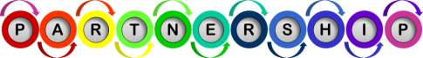
Tests of Change / Interventions
- Hold an annual meeting in a targeted community with identified F,Y&C members to brief attendees on your work and provide resources and referrals.
- Identify and support a community connector or cultural broker to work with you to get your program information into targeted communities and groups of people.
- Host regular listening sessions in communities to hear from F,Y&C members about what their concerns are; document those concerns; consider those concerns as programs are developed and improved.
- If you have a physical space, host occasional open houses to invite F,Y&C members in to check out programs in a welcoming and informal atmosphere; invite community connectors to be present.
- Invite F,Y&C members to review and comment on proposed programs and written materials; form advisory committee to regularly do this work.
- Review meeting times, locations, accessibility, transportation, childcare, etc. to ensure that F,Y&C member can easily participate.

Family, Youth and Community Partnership
Driver #1:
Driver #2:
Driver #3:
Driver #5:
Driver #4:
Driver #6:
Aim
Wisconsin Title V
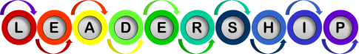
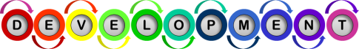
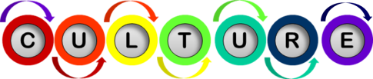
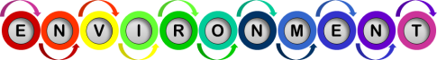
- Edit Mission, Vision, Strategic Plan and Communications to emphasize value of F,Y&C engagement.
- Use a hybrid of top down and bottom up leadership style to support authentic engagement.
- Use the Whole Leadership Framework to establish systems and policies for consistent implementation of F,Y&C engagement.
- Dedicate program funds to reimburse F,Y&C members for sharing their lived experience and for enhancing their leadership skills.
- Include F,Y&C members to help write focus group questions, join group discussion, review group feedback, and help test recommended changes.
- Have F,Y&C members help write survey questions, assist with distribution, review feedback, and help test recommended changes.
- Invite F,Y&C members to join program staff to discuss using an Impact Matrix to figure out which projects might be easy to implement and have high impact.
- Hold a Brainwriting session to generate innovative ideas to address a problem with F,Y&C members.
- Ask F,Y&C members to join program staff in a 5 Whys session to get to the root cause of a problem.
- Host a focus group on physical setting, website, or social media: F,Y&C members help write focus group questions, lead group discussion, review group feedback, and test recommended changes.
- Form a review panel of F,Y&C members who review materials from the program before they are shared with the public.
- Invite cultural brokers to share information with program staff to improve cultural and linguistic competencies.
- Create a space that reflects respect for the unique cultures of the people being served including their comfort and confidentiality.
- Expand opportunities for direct communication between F,Y&C members and the program staff.
- Use gender-preferred pronouns to support equity and respect.
- Acknowledge days of religious, spiritual and cultural observance when setting meeting schedules or hosting events.
- Provide opportunities for F,Y&C members to articulate concerns, create process for submitting anonymous feedback on policies, programs, culture or other work-related issues and encourage the use of this tool.
- Rotate who runs meetings; chances are you will end up with different perspectives shared.
- Engage with a diverse group of stakeholders providing the necessary support for full inclusion which may include accessibility and language interpretation.
- Acknowledge that social and economic differences can offer a variety of strengths and perspectives.
**F,Y&C = Family, Youth and Community

Program Leadership

Continuous Improvement

Professional Development

Culture of Inclusion and Equity
- Invite F,Y&C members to join program staff to plan and participate in training on equity, diversity and engagement.
- Identify individualized training plans to advance program staff members’ understanding of equity and engagement to include how they will integrate concepts into their work.
- Provide formal recognition of F,Y&C members of their skills and contributions to the program.
- Re-evaluate position descriptions and job qualifications to give credit for lived experience and recruitment plans for positions are expanded to reach a broader group of potential applicants.

Program Environment
Family, Youth, and Community Engagement
By December 31, 2025, 75% of Wisconsin’s MCH funded programs are making progress or have embedded concepts of family, youth and/or community member engagement on at least three (3) indicators of the Community Engagement Assessment Tool because programs that respond to participants’ experiences are more effective.
Family of Measures (Indicators):  Family, Youth and Community Partnership  - Respectful, Trusting Relationship Between Staff and the People They Serve  - Family, Youth and Community Members Work in a Cooperative Way and Have Shared Goals  - Commitment to Social Support Systems Within the Program and Larger Community  Culture of Inclusion and Equity  - Commitment to Health Equity  Program Environment  - Cultural and Language-Based Responsiveness  - System of Regular Communication with Families, Youth and Communities  - Welcoming and Inviting Setting (Physical Space and Online)  Program Leadership  - Family, Youth and Community Engagement as a Shared Priority  - Increase Success in Engaging Families, Youth and Communities  - Group Decision-Making Happens  - Support for Developing New Skills  Professional Development  - High-Quality Training for All Staff  - Career Pathways and Leadership Opportunities  Continuous Improvement  - Data About Engagement Efforts and Results Drives Decision-Making | How to Conduct Tests of Change  The ideas listed on the right hand column of this driver diagram are intended to be potential tests of change, rather than tasks to be checked off a to-do list.  Do two things to make sure you are conducting a test of the change (rather than a task):  - Make a prediction BEFORE you make the change as to what you think will happen  - Gather data as the change is made.  Example: Testing use of program funds to support participation of family, youth and community members -  - Prediction: If we reimburse family, youth and community members at a rate of $40/hour, five members will participate in our next meeting as compared with the previous average of two members when no reimbursement was offered.  - Data gathering: Six family, youth and community members participated in the meeting.  This was a successful test of change – your result (6 members) exceeded your prediction (5 members).

